De Montfort University

Nishant Chavda

P14177216

Final Report

Table of Contents

1. Introduction 2

2. Ethical Reviews 3

3. CV Development 4

3a. Personal profile 4

3b. Education 4

3c. Work Experience and Skills/Achievements 4

4. The life cycle of my part of the system (Appointments) 5

4a. Designing My Part 5

Use case diagram/description 5

Sequence diagram 5

Class diagram 5

4b. Creating our system 5

5. Critical Review of your Project Performance 6

5a. Time Management 6

5b. Planning 6

5c. Resources 6

5d. Meetings 6

6. Critical Review of the Module 7

6a. what worked? 7

6b. What didn’t? 7

7. Conclusion 8

8. Appendix 9

Updated CV 9

# Introduction

On this course we have been assigned to develop a system for our company that we have created. Each member of our team has been assigned different parts of the system and in this report I’ll be discussing my performance in designing/creating my part which was appointments. As well as my own performance, I’ll be talking about the overall module, discussing my thoughts on what worked well and what could be improved. Finally I’ll be talking about the ethical view of software’s and the development of my personal CV.

# 2. Ethical Reviews

All companies that have customer information are required to keep their information private from anyone. They must follow data protection and privacy to keep their customers safe from fraudsters. In many cases, companies information have been leaked which then affects their customer. Once people get into the company, customer personal information are at risk.

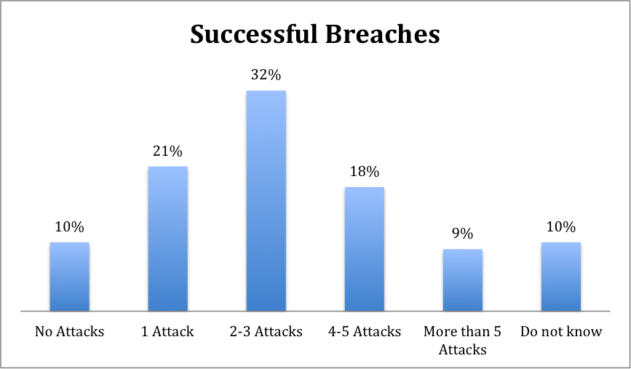

From the graph above there are still people trying to hack into companies to get details about their customers. To reduce the chance of this happening we should design a strong security system which help defend again unauthorised personnel.

# 3. CV Development

During the making of our system I made some improvements to my CV, adding in skills and achievements that I accomplished during this project. Furthermore I attended CV workshops, getting valuable feedback to develop my CV even further.

## 3a. Personal profile

My first attempt of my personal profile was good, but there was a lot of feedback given by peers and the placement team that I could make to further develop my profile. They both said that I had too much information and I should shorten it down to a paragraph. I took this advice and made the profile shorter, making sure my point are quick and brief. After I was confident that the changes I made were good I visited the placement team for the second time and they were pleased with the improvements I made.

## 3b. Education

When looking at my CV my layout of my current and past education was not organized making this section unprofessional. My peers agreed and I made sure that I changed this, making the education part easy to read by employers.

## 3c. Work Experience and Skills/Achievements

These parts of my CV had chunks of paragraphs which the placement team didn’t like and recommended that I bullet point the main parts so that employers can quick read and identify the important information. These changes I made making my CV clear and straight to the point so that companies don’t get bored when reading through. Also I added extra achievements and skills that I learnt during this project.

# 4. The life cycle of my part of the system (Appointments)

As mentioned our team was assigned different parts of the system and my role was to design and implement the appointments. Appointments can be booked by user on the business website so this meant that our system must have a front end that will allow users to book available appointments. As well as users booking appointments, staff must be able to add appointments to the website for users to book. This meant that there must be a back end for staff to add bookings and also make bookings for customers.

## 4a. Designing My Part

Before I jumped into starting our system I made sure I planned out our system using different diagrams. This made it clear to both me and my team, the different parts of the appointments. The diagrams we used:

### Use case diagram/description

This shows me clearly what actors interacted with the system. This is how we found out that the appointment sections must have both a back and front end as both the user and the staff interact with the appointment. It also showed the different actions that can be done by each actor, making it easier for me to build the system based on what each actor can or cannot do.

The use case description showed me the process taken by both the user and staff to complete a certain task. It’s a step by step guide to how they do that task and the error that appear if something is incorrect. This again shows me each step so that creating the system become easier. It also tell me when and where to place error to improve user awareness.

### Sequence diagram

The sequence diagram aided me in understanding what each process goes through to be complete. It shows the way tasks are done and how it flows through the system and back to receive the information.

### Class diagram

Creating a class diagram as a group clearly showed the relationship between each part of the system. It made it clearer to see what part of the system links to another part.

## 4b. Creating our system

After I’d planned my system, I made a start on creating both the front and back end of my part of the system. This involved creating forms for the back end for staff and html web pages for the front end for user/customer. The front end of the system was more complex as this was the end where our system information was kept so that customers know about the company. The back end was just a simple application for staff to perform simple tasks and had no information about our company. During the making of the system I carried out TDD which made the code more reliable and caused fewer defects. I could also say it improved my design.

# 5. Critical Review of your Project Performance

During the building of this project there are things that I could have done to improve the process taken to create my part.

## 5a. Time Management

Time management was a big thing when it came to developing this system. I didn’t manage my time well and due to this some parts of the system are good but others are not the best. I spent too much time on some parts of the project, causing other parts to be affected. I need to make sure that next time I mange my time equally between the different parts of the system to ensure that the whole system.

## 5b. Planning

I feel that I spent too much time on my planning and designing part of the system which reduced the time I had in creating the final system. Planning is a big part of creating a system so I made sure that I spent a good amount of time on it to make sure that I create the most efficient system. But I know now that I spent too much time on planning and that is what I would change. I would make sure that I planned my system using design diagrams but to make sure I don’t spend too much time on it.

## 5c. Resources

When creating this system I didn’t use a range of resources outside of university which effected the time a spent on a certain bit of the system. If I made use of other resources I could have done parts of the system quick and better. Next time I’ll make sure I expand my resources to get the best out of my system.

## 5d. Meetings

During this system development our team did meet up to discuss our progress with our own parts of the system. This was a good time to discuss any problems or issues we had with the system. I feel that if we had more of these meeting, we would have been able to create a better and more sufficient system.

# 6. Critical Review of the Module

During my time spent on this module there were things that worked well and things that’s I felt was not.

## 6a. what worked?

* TTD phase test - helped us understand the principle of test driven development and helped us to manipulate this to our part of the system.
* Team projects – helped us develop our skills in working with a team. it made us understand the importance of team meetings to make sure that everyone is on the right track on their part of the system.
* Module Questions – this worked very well as it’s a great way for tutors to help their student during holiday seasons. I was really impressed on how you did this and I would recommend other tutor to do this as it will really benefit the student.

## 6b. what didn’t?

* Lectures – having stopped the lectures around January, I would have recommended that you have an extra lab session so that students have more time to ask you questions related to assignments and modules.
* Sprint logs – I didn’t think having regular sprint logs was the best decision. I would have recommended that you have team meetings with us to discuss how we are progressing as a team.

## 7. Conclusion

To conclude, I’ve explained my bit of the system, talking about the problems I faced and the improvements could make next time with a project like this. Also discussed the ethical reviews and the changes I made to my CV. Finally I discussed my own performance on this project and also the feedback for the overall module.

## 8. Appendix

### Updated CV

**Nishant Chavda**

**Mobile Number:** 07599862477 29 Bellflower Road

**Telephone Number**: 01162743532 West Hamilton

**Email**: [p14177216@dmu.ac.uk](mailto:p14177216@dmu.ac.uk) Leicester

LE5 1TS

**Personal Profile**

A hardworking intellect who is dedicated to achieving both business and personal goals in a software engineering placement. An enthusiastic, self-motivated induvial who is determined to broaden his knowledge of programming languages and software’s. On the whole a devoted person that can apply my skills and qualities effectively to accomplish objectives that are set before me.

**Education**

**De Montfort University**

BSc (Hons) Computing **2014 – 2018**

|  |  |
| --- | --- |
| **1st Year Modules** | **2nd Year Modules (pending results)** |
| Database Management and Reporting **72%** | Advanced Programming |
| Visual Web Development **68%** | Multimedia Technology |
| Business Technology **66%** | Project Management & Development |
| Information Systems Development **57%** | Interactive Systems Design & Evaluation |

**Gateway Sixth Form College 2012 - 2014**

A Level: Accounting (E), IT (D) and Statistics (C)

**Soar Valley College 2007 - 2012**

11 GCSEs A*-C including English, Mathematics and IT

**Work Experience**

**Crew Member: Mc Donalds, Leicester 2013 – present**

* Providing exceptional customer service: dealing with customer enquiries, complaints and refunds
* Till work: communicating with customers and dealing with payments
* Taking control of the kitchen when told too, to ensure other employees are carrying out their dedicated tasks
* Responsible for preparing and displaying fresh, well- presented foods under pressure
* Tasked with organising morning equipment/foods before the store is opened
* Working during peak times to support other staff members in serving quick, good quality items
* Cashing up and balancing the companies safe every morning
* Following company procedures and health and safety regulations
* Stock controlling following the FIFO method
* Assigned to other Mc Donalds stores to cover for absent employees

**Shop Assistant: Charnwood Mini Market, Leicester 2010-2011**

* General shop assistant, organising and tidying the shop floor
* Stock controlling, ensuring I follow the FIFO method
* Assisting customers with any enquires
* On till, handing cash payments
* Sorting stocks in back room making sure that items that need to go out first are placed at the front
* Working independently in the shop with little-to-no supervision

**Skills/Achievements**

* **Communication:** Interacted with many customers to assist them with any needs and problems that they encountered. Got to socialise with various people including other workers from different backgrounds on both the shop floor and behind the till which greatly developed my interpersonal skills.
* **Time management and ability to prioritise:** Had to balance my time between the demands of work with study commitments. This included completing tasks and assignments within the required time scale, showing I am able to effectively prioritise my time.
* **Ability to work under pressure:** Completed multiple tasks under difficult and stressful situations whilst at work and university.
* **Teamwork:** Was part of many group assignments during my time at university and all of them was a success, achieving at least 60%+ which demonstrated my ability to cooperate well with others and to share knowledge and information to achieve the specifications set out by the examiners.
* **Organisation and Money management:** Assisted in making structured lists of relevant items to buy for the shop and was involved in handling money behind the till.
* **Adaptability and Initiative:** Majority of the time I had to work independently in the shop with little-to-no supervision and therefore had to use my own initiative to tackle problems that occurred
* **Computing Skills/languages:** Excellent knowledge and experience of computer languages such as C#, Visual basic and basic knowledge in java script. Highly skilled with working with software’s such as Visual Studio, Dreamweaver, notepad++, Photoshop and Enterprise Architecture

**Achievements/Interests**

* **Duke Of Edinburgh:** Achieving bronze and silver awards
* **St John ambulance:** receiving a first aid certificate
* **Driving Licence:** Full and clean
* Regularly attend the gym which motivates me to keep fit and relieves any stress I’m faced with.
* Into many sports such football, snooker, tennis and formula 1.

**REFERENCES**

References are available on request